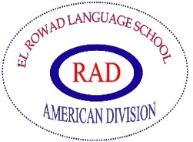
El Rowad Language School – American Division
Academic Year 2020-2021
Students’ subject selection
G. 10

Dear students and parents,
As the school’s main goal is the welfare of the students as well as maintaining a high standard of education that guarantees the best future for our students, it is in the schools best interests to help the students make their choice of the subjects that help them join the college they wish.
It has to be noted that a wise choice has to be carefully made; parents and students are responsible for their choices, once the choice has been made, it cannot be changed under any circumstances because of the availability of books, number of students and division of class.
We wish our students a wise choice and a successful future.
N.B. Students are welcomed to seek the advice of their teachers before making their choice.
Grade 11
(Please, put a tick next to one subject only in this group)
1 | 2
Physics | Psychology

(Please, put a tick next to one subject only in this group)
1 | 2
Mechanics | Accounting

Grade 12
(Please, put a tick next to one subject only in this group)
Group 1
Chemistry | Economics

(Please, put a tick next to one subject only in this group)
Group 2
Advanced Biology | Sociology

Student's Name: ------------------------------------
Parent's Signature: --------------------------------
American Division Administration

